# **Educational Organisation Using ServiceNow**

* **Project description:**

The Educational Management System is a comprehensive platform designed to streamline administrative tasks within educational institutions. It facilitates efficient management of student and teacher data, simplifies the admission process, and provides tools for monitoring student progress.

* **Steps for the instance:**

1.Sign up for a developer account on the ServiceNow Developer site “https://developer.servicenow.com”.

2.Once logged in, navigate to the "Personal Developer Instance" section.

3.Click on "Request Instance" to create a new ServiceNow instance.

4.Fill out the required information and submit the request.

5.You'll receive an email with the instance details once it's ready.

6.Log in to your ServiceNow instance using the provided credentials.

7.Now you will navigate to the ServiceNow.

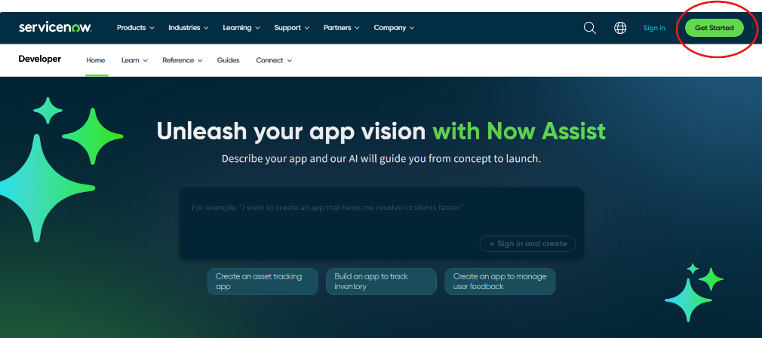

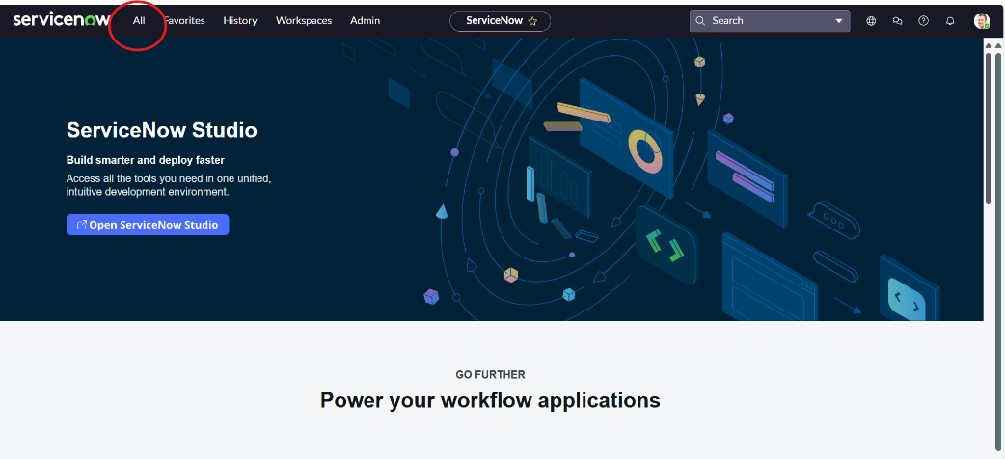

* **Create Update set:**

1. Navigate to All → Local Update Sets from the left navigation pane in ServiceNow.
2. Click on the New button to create a new update set.
3. In the form that appears, fill in the details as follows:
4. Name: Educational Organisation
5. Click on Submit to save the update set.
6. After saving, click on the newly created update set and select “Make Current”.  
   This ensures that all the changes you make (tables, forms, scripts, etc.) are stored in this update set.

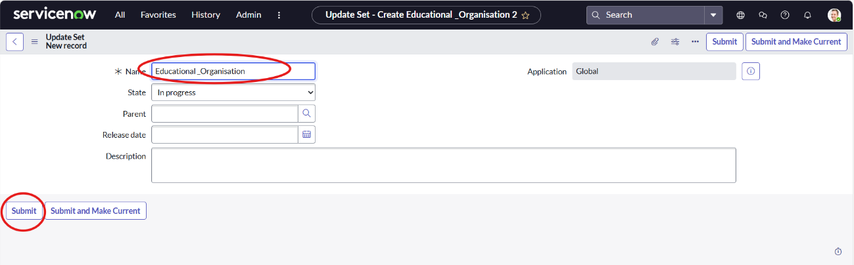

* **Create a table:**

1. Salesforce Table
2. Admission Table
3. Student Progress Table
4. **Creating Salesforce Table**
5. Go to All → Tables → New.
6. Enter Label: Salesforce → Click on Name (API name auto-generates).
7. Add required columns → Double-click to edit label → Choose correct Type.
8. Set Display = True for Admin Number → Right-click top bar → Save.
9. Go to Controls → Enable Extensible.
10. Open Admin Number → Advanced View → Default View → Enable Use Dynamic Default → Choose Get Next Padded Number → Update.
11. For Grade column → Open Choices → Add Label, Value, and Sequence.

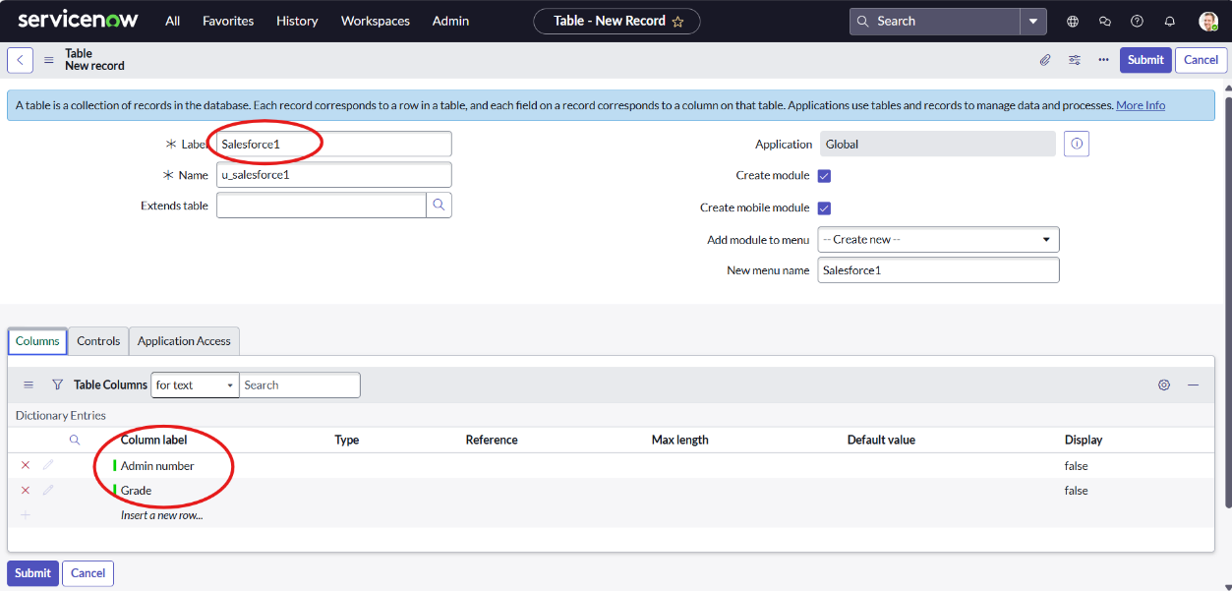

1. **Creating Admission Table**
   1. Go to All → Tables → New.
   2. Enter Label: Admission.
   3. Select Extends Table: Salesforce.
   4. Tick Add module to menu → Salesforce.
   5. Create all required fields for admission details.
   6. Add choices for:

Admin Status

Pincode

Purpose of Join

School

School Area

✅This table stores all student admission details linked to the Salesforce table.

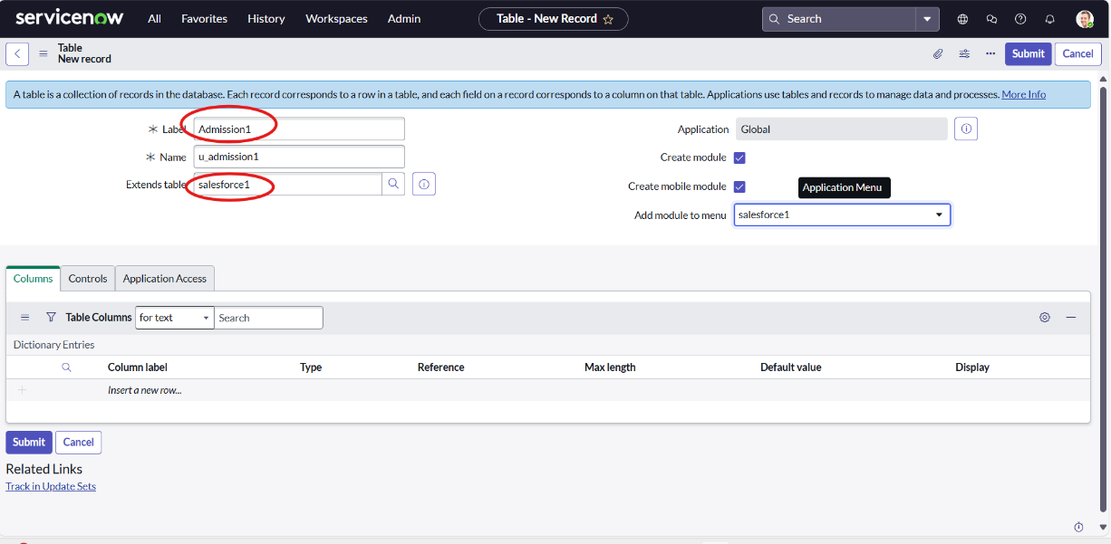

1. **Creating Student Progress Table**
2. Go to All → Tables → New.
3. Enter Label: Student Progress.
4. Tick Add module to menu → Salesforce.
5. Create all required fields for student marks and progress details.

✅ This table stores each student’s marks, total, percentage, and result details.

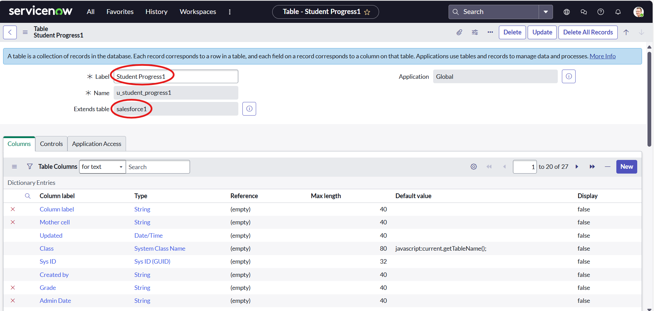

* **Form Layout**

1. Open the **Student Progress Table** page.
2. Click on **Form Layout**.
3. Click on **Admission Number [+]**.
4. From the **Available** list, move the required **Admission Number fields** to the **Selected** side.
5. Click **Save**.

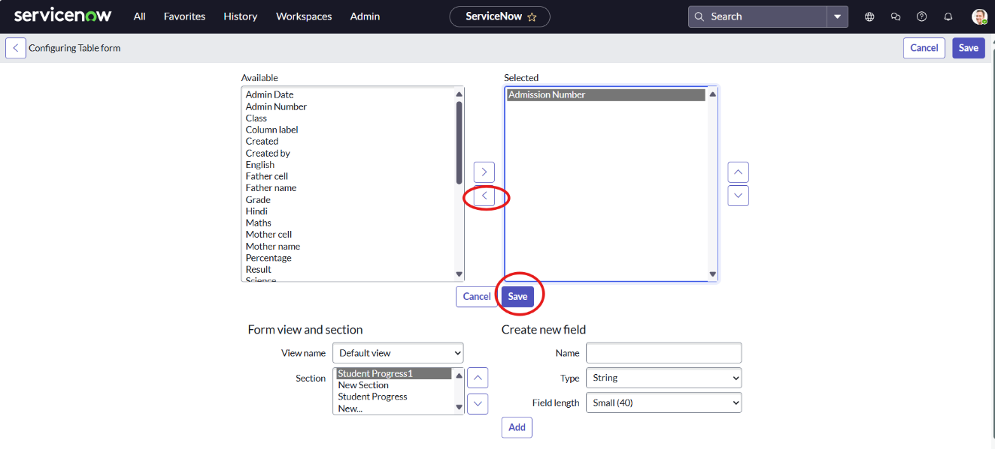

* **Form Design**

1. Salesforce Table
2. Admission Table
3. Student Progress Table
4. **Creating Form Design for Salesforce Table**
5. Go to **All → System Definition → Tables**.
6. In **Label Search**, find and open **Salesforce**.
7. Right-click on the top toggle → **Configure → Form Design**.
8. In the dropdown, select **Salesforce (u_salesforce)**.
9. **Drag and drop** the required fields to the left side.
10. Click **Save**.

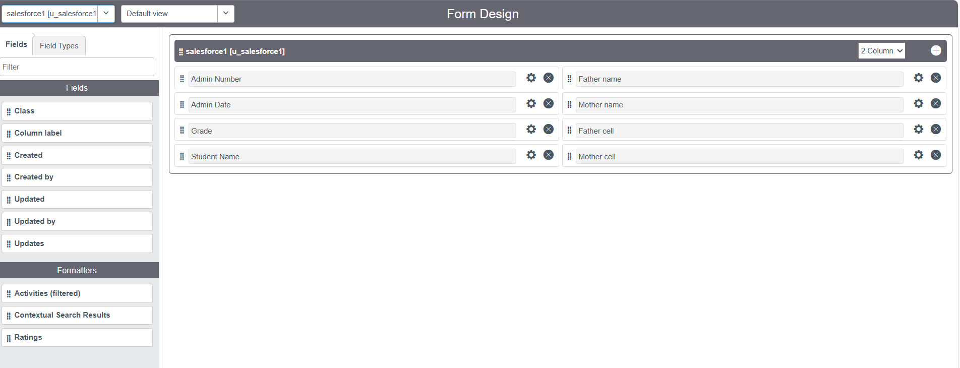

1. **Creating Form Design for Admission Table**
2. Follow the same steps as in Activity 1 (Salesforce Form Design).
3. Open the Admission Table and go to Configure → Form Design.
4. Arrange the fields as shown in the given layout.
5. Click Save.

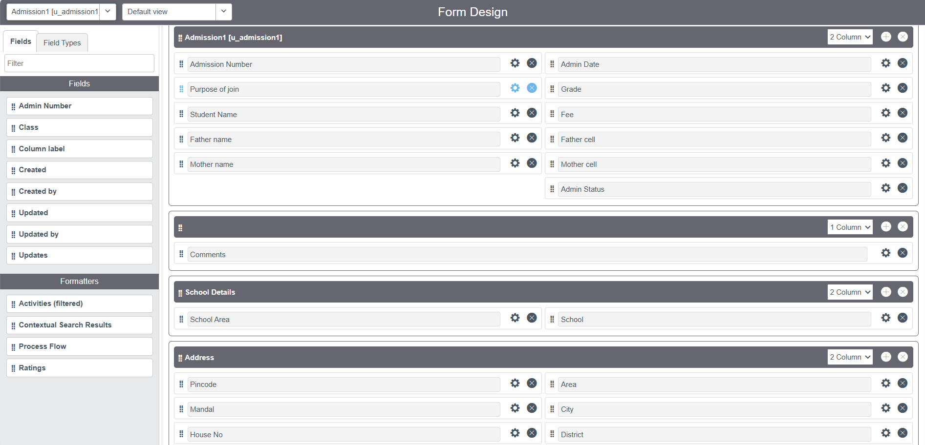

1. **Creating Form Design for Student Progress Table**
2. Follow the same steps as in Activity 1 (Salesforce Form Design).
3. Open the Student Progress Table → Configure → Form Design.
4. Arrange the fields as shown in the layout.
5. Click Save.

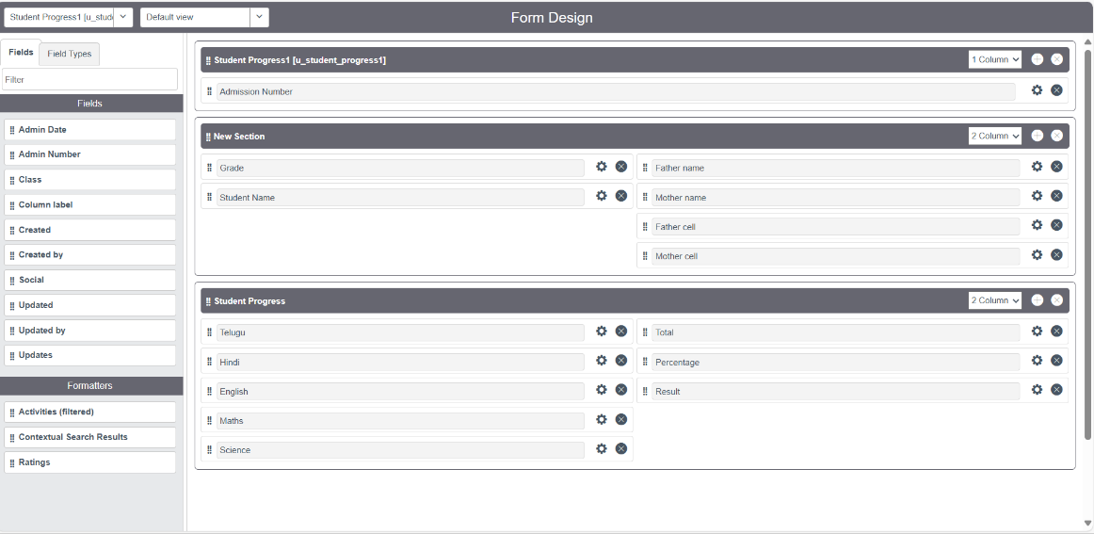

* **Number Maintenance**

1. Go to **All → Number Maintenance → New.**
2. Fill in the required **details** (like Table name, Prefix, Number format, etc.).
3. Click **Submit.**

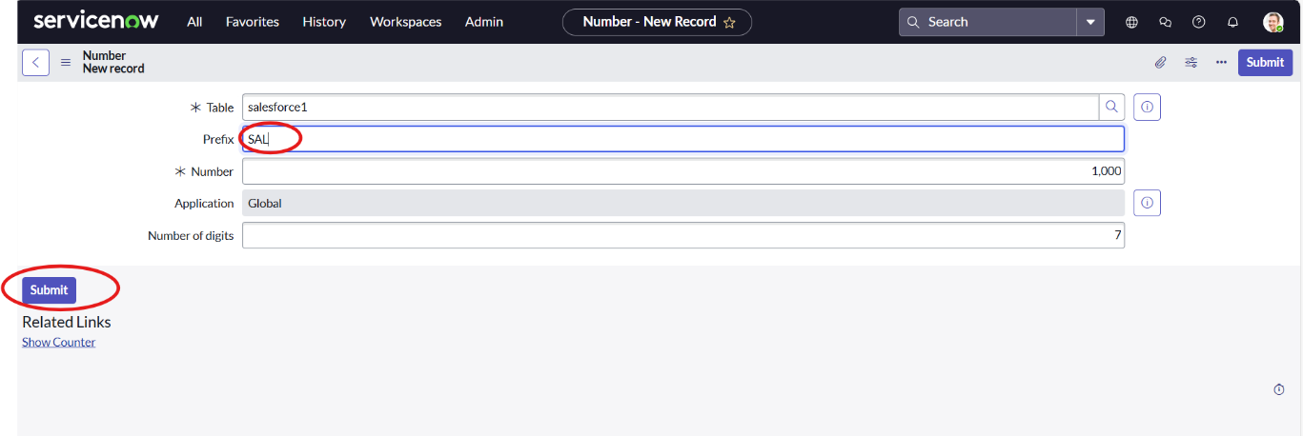

* **Process Flow**
  1. Go to All → Process Flow → New.
  2. Fill in the required details.
  3. Right-click on the top toggle and click Save.
  4. Replace the Name and Label as shown below, then click Insert and Stay each time.
* Joined
* Rejected
* Rejoined
* Closed
* Cancelled
  1. Arrange the order as:  
     New → In Progress → Joined → Rejected → Rejoined → Closed → Cancelled

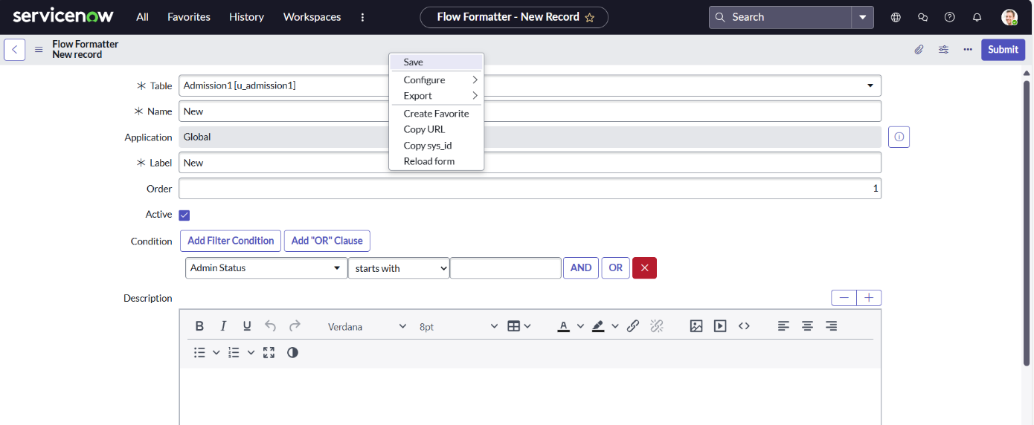

* **Client Script**

1. Auto Populate
2. Pincode Update
3. Disable Fields
4. Total Update
5. Result
6. Percentage
   * 1. **Creating “Auto Populate” Client Script for Admission Table**
7. Go to **All → Client Scripts → New**.
8. Fill in the **details** as given.
9. Enter the **code** in the script section.
10. Enable **Isolate Script**.
11. Click **Save**.

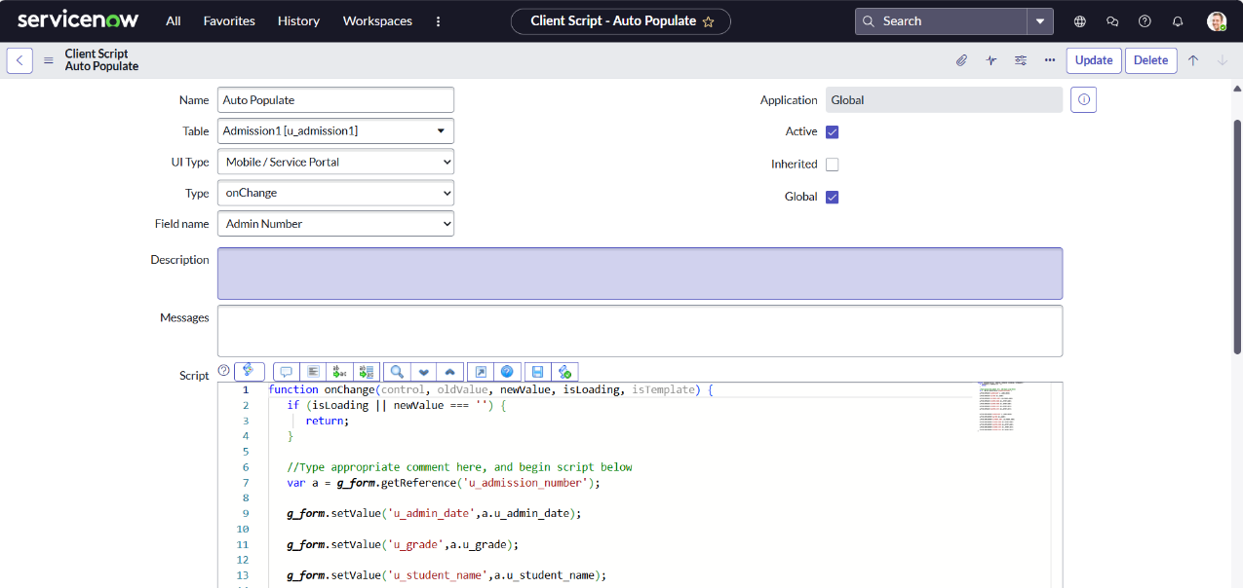

* + 1. **Creating “Pincode Update” Client Script for Admission Table**

1. Fill the **details** as given.
2. Write the **code** as shown.
3. Enable **Isolate Script**.
4. Click **Save**.

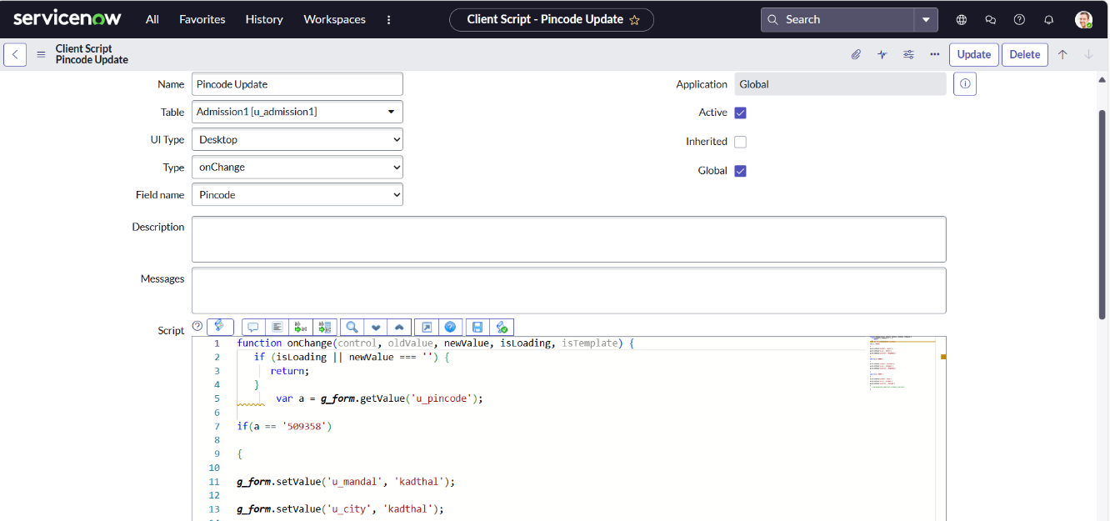

* + 1. **Creating “Disable Fields” Client Script for Student Progress Table**

1. Fill the **details** as given.
2. Write the **code** as shown.
3. Enable **Isolate Script**.
4. Click **Save**.

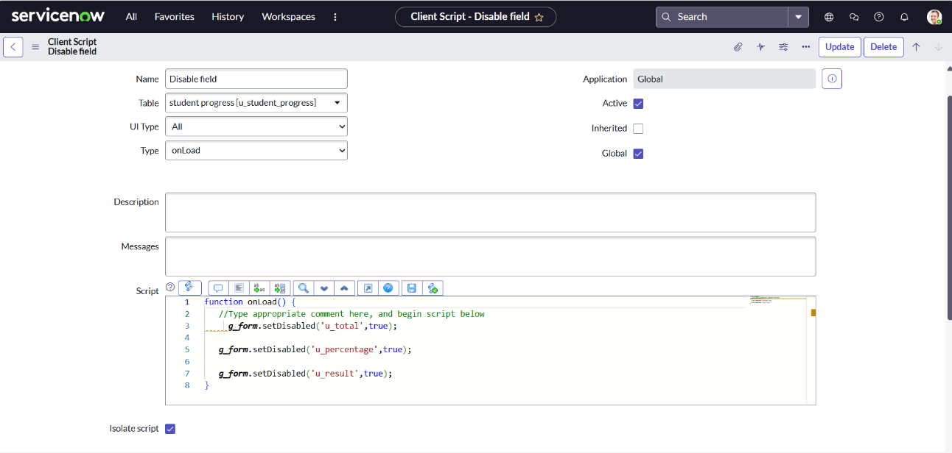

* + 1. **Creating “Total Update” Client Script for Student Progress Table**

1. Fill the **details** as given.
2. Write the **code** as shown.
3. Enable **Isolate Script**.
4. Click **Save**.

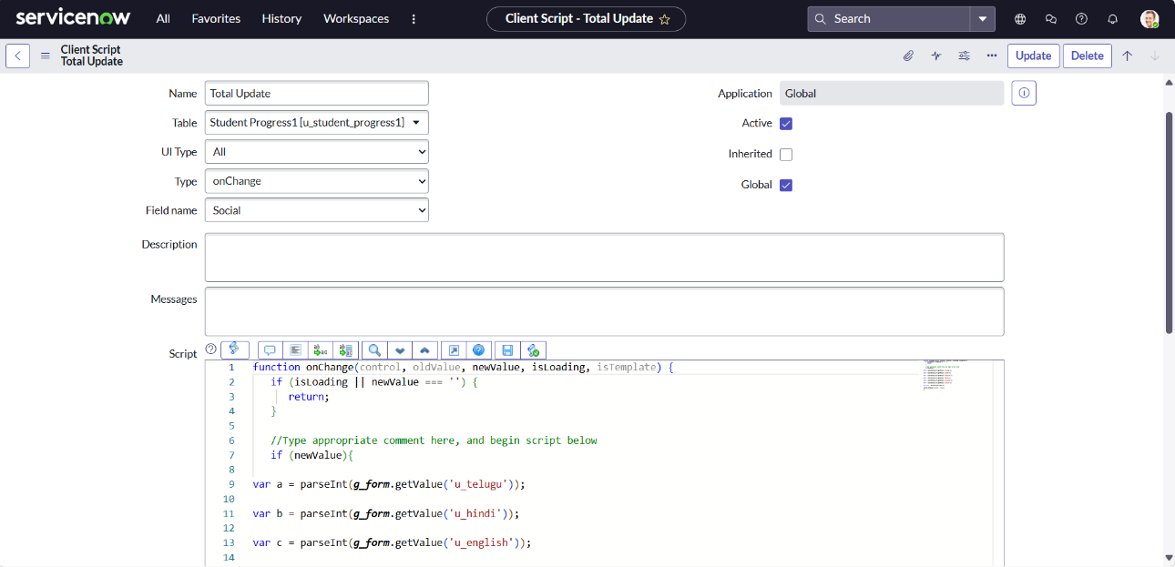

* + 1. **Creating “Result” Client Script for Student Progress Table**

1. Fill the **details** as given.
2. Write the **code** as shown.
3. Enable **Isolate Script**.
4. Click **Save**.

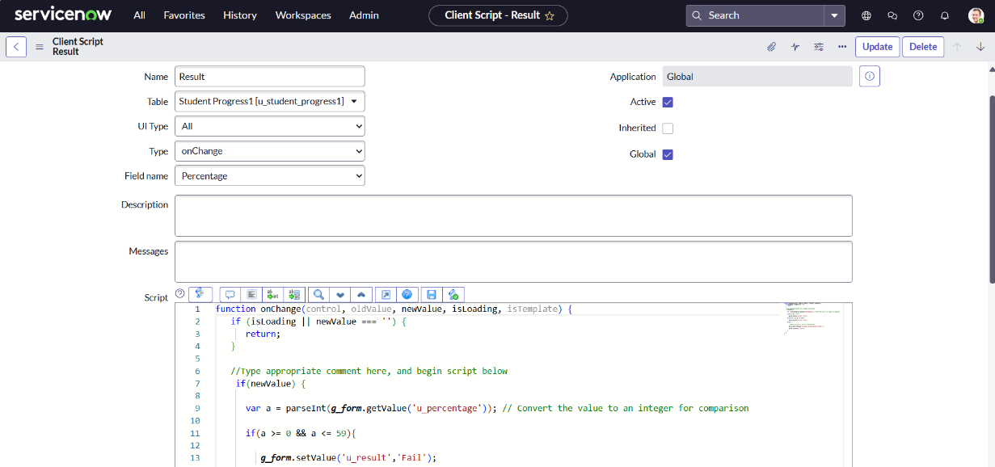

* + 1. **Creating “Percentage” Client Script for Student Progress Table**

1. Fill the **details** as given.
2. Write the **code** as shown.
3. Enable **Isolate Script**.
4. Click **Save**.

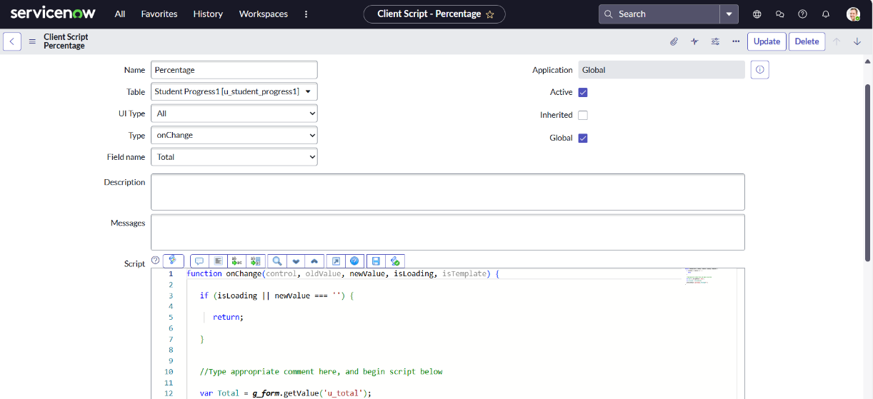

* **Result**

The Educational Organisation System was successfully created using ServiceNow. All modules such as Salesforce, Admission, and Student Progress were designed and configured with proper tables, forms, process flows, and client scripts.

The system can:

* Store and manage student and admission details efficiently.
* Automatically generate admin numbers and update student records.
* Display admission status and student progress in an organized manner.
* Simplify data entry using auto-populated and dynamic fields.



 

 

 